k8s-09 tasks.
- Execute all the steps shown in video.
Ingress:
========
Ingress will helps us to expose the applciations and manage
external access by providing http/https routing rules to the services
within a k8s cluster.

Ingress controller:
==================
Nothing but a load balancer which is responsible for implementing and managing Ingress resources.
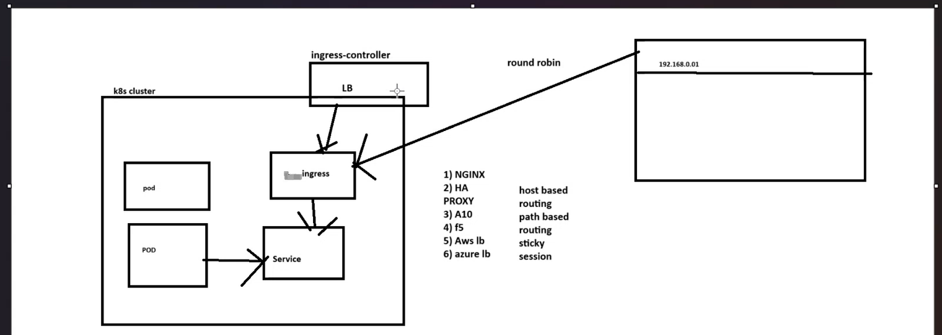

- Created yaml file
Deployment.yaml
Add
apiVersion: apps/v1
kind: Deployment
metadata:
name: nginx-deployment
spec:
replicas: 1
selector:
matchLabels:
app: nginx
template:
metadata:
labels:
app: nginx
spec:
containers:
- name: nginx
image: nginx:latest
ports:
- containerPort: 80
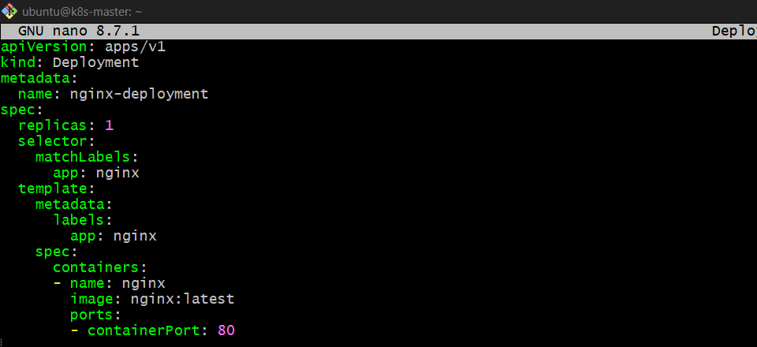

3.apply
Kubectl apply -f deployment.yaml 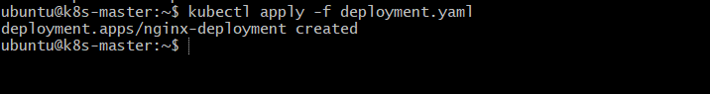
4.kubectl get pods
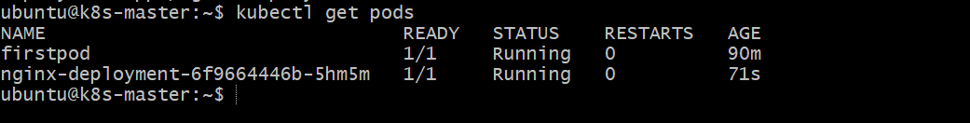

5. How can we expose this nginx-deployment-6f9664446b-5hm5m using server.yaml
6. create one service.yaml file
Add
Service.yml
===========
apiVersion: v1
kind: Service
metadata:
name: nginx-service
spec:
selector:
app: nginx
ports:
- protocol: TCP
port: 80
targetPort: 80
nodePort: 30001
type: NodePort 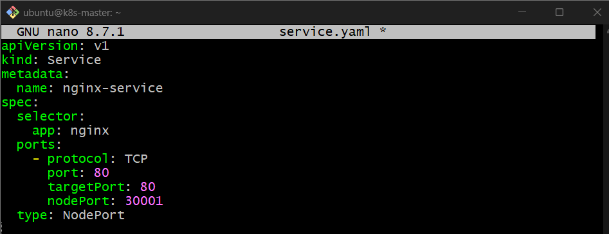
7. apply
Kubectl appy -f servic.yaml
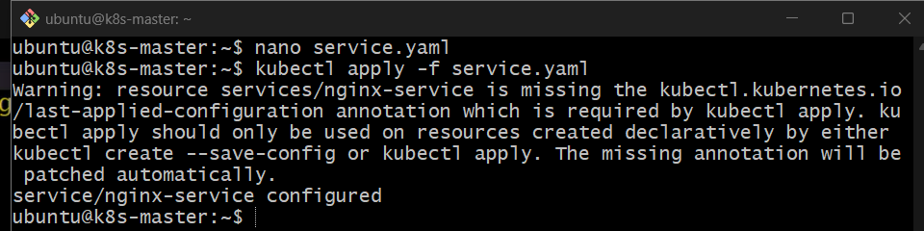
8.check
Kubectl get svc
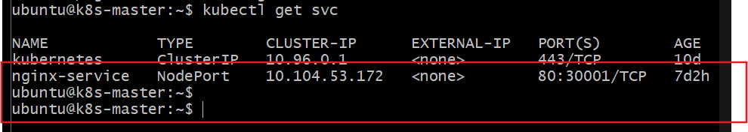

Expose this to outside k8s
Ec2 master pub ip and port 30001
http://44.200.35.208:30001/
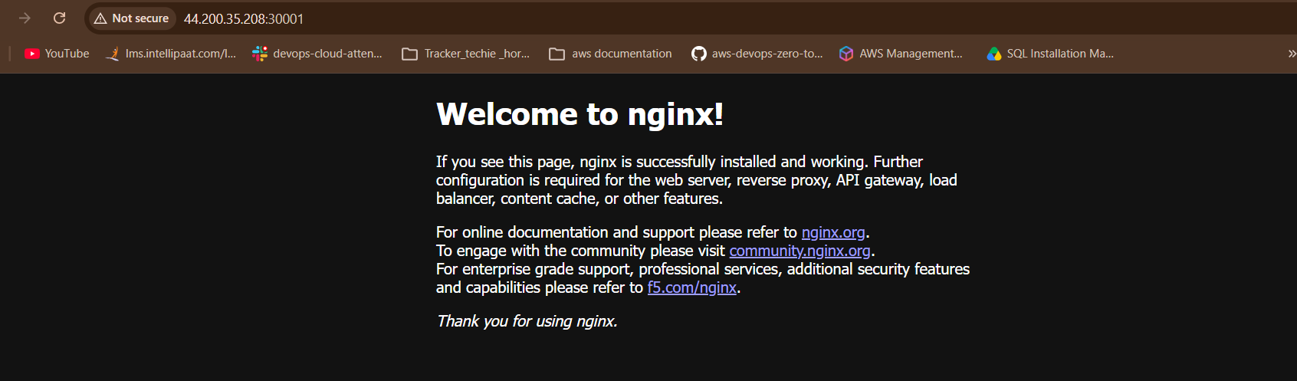

9. create ingress.yaml file
Add
Ingress.yml –host base path
===========
apiVersion: networking.k8s.io/v1
kind: Ingress
metadata:
name: nginx-ingress
spec:
rules:
- host: example.com
http:
paths:
- path: /
pathType: Prefix
backend:
service:
name: nginx-service
port:
number: 80 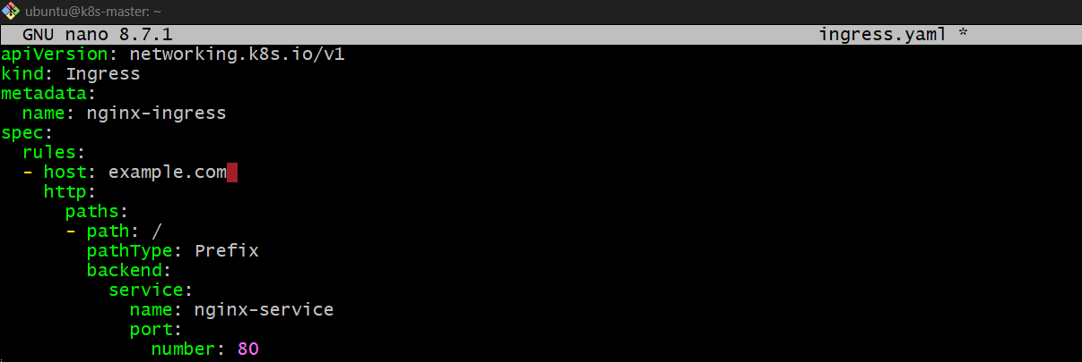

10.To enable ingress on minikube: ( we need map Ingress controller to Ingress service)
NGINX Ingress Controller
1. Install Ingress Controller –path base
kubectl apply -f https://raw.githubusercontent.com/kubernetes/ingress-nginx/controller-v1.15.1/deploy/static/provider/baremetal/deploy.yaml 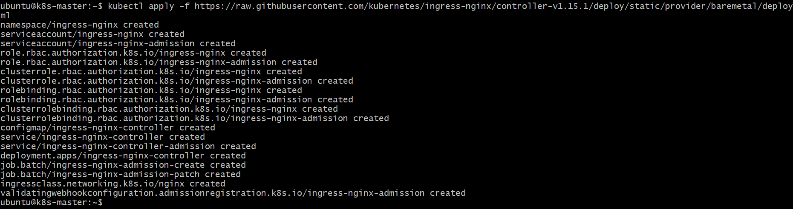
2. Verify Controller
kubectl get pods -n ingress-nginx
Wait until:
1/1 Running 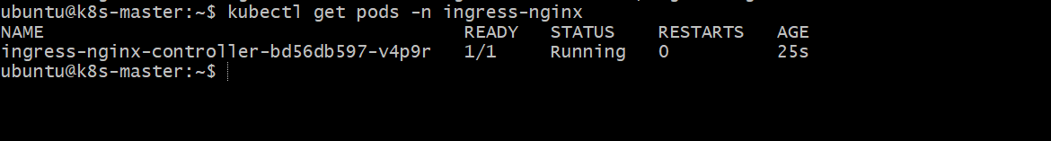
3. Check Ingress NodePort
kubectl get svc -n ingress-nginx
Example:
ingress-nginx-controller NodePort ... 80:32080/TCP
Here 32080 is the HTTP NodePort. 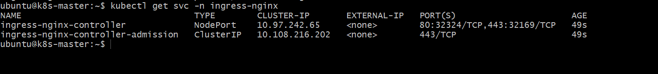
4. Create Ingress YAML
nano nginx-ingress.yaml
apiVersion: networking.k8s.io/v1
kind: Ingress
metadata:
name: nginx-ingress
spec:
ingressClassName: nginx
rules:
- http:
paths:
- path: /
pathType: Prefix
backend:
service:
name: nginx-service
port:
number: 80 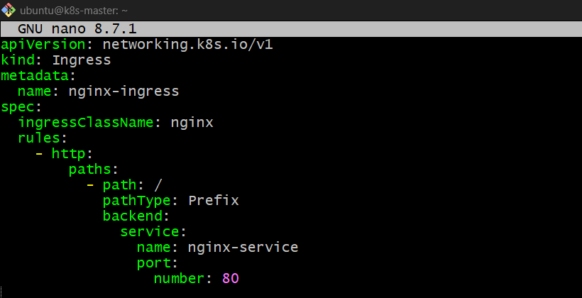
5. Apply
kubectl apply -f nginx-ingress.yaml
6. Verify
kubectl get ingress 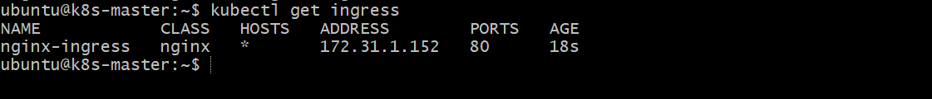
kubectl describe ingress nginx-ingress 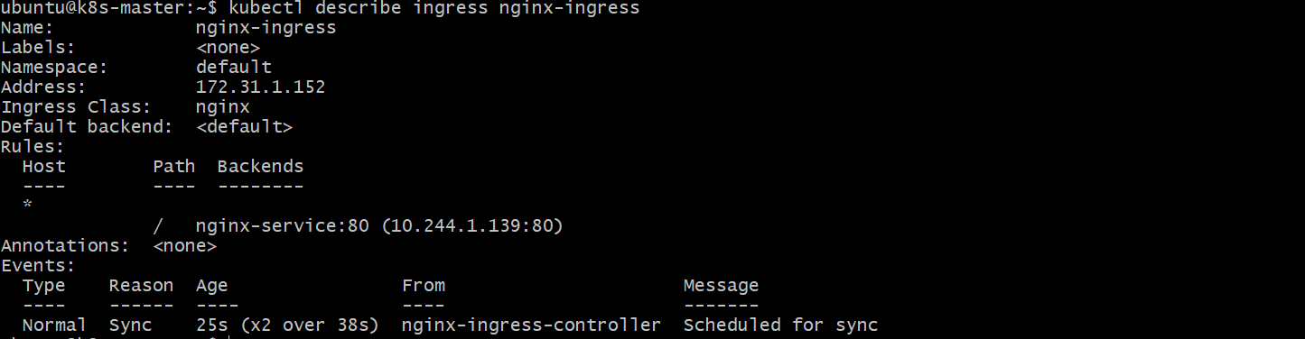
7. Test
From your EC2 master:
curl http://172.31.13.164:32080 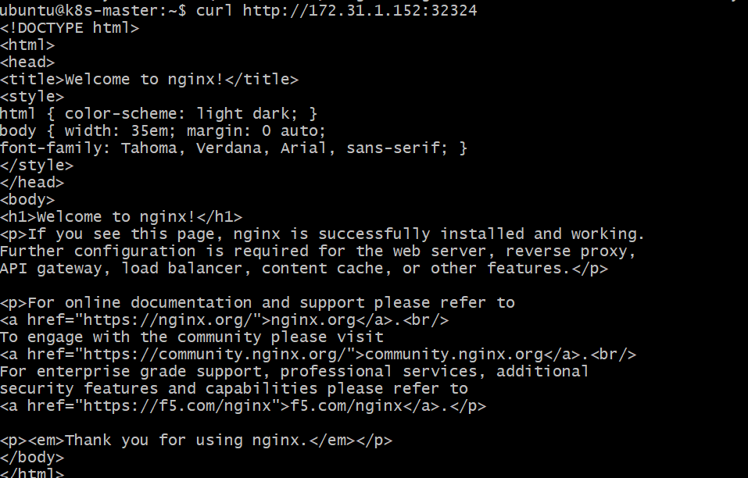
You should get the Nginx welcome page HTML.
8. Browser Without Public IP
From your laptop:
ssh -L 32080:172.31.13.164:32080 ubuntu@<EC2-SSH-ADDRESS> 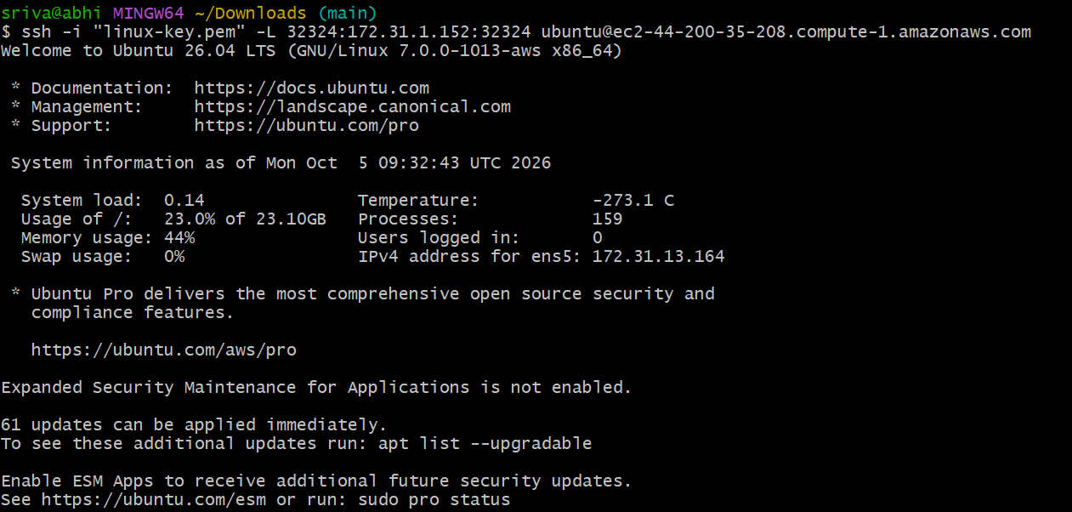
Then open:
http://localhost:32080 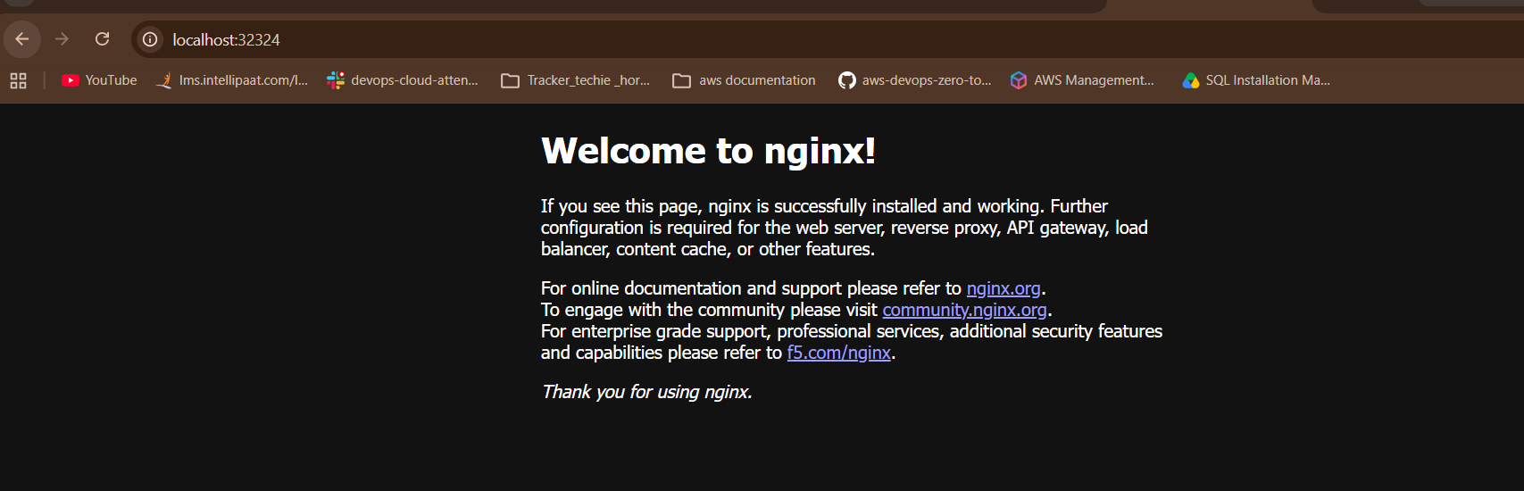
Flow
Browser
↓
NGINX Ingress Controller
↓
nginx-service:80
↓
Nginx Pod
Remember: Ingress = routing rules, Ingress Controller = NGINX, Service = Pod access.

2.Host-Based Ingress
1. Create Ingress YAML
nano host-ingress.yaml
Use:
apiVersion: networking.k8s.io/v1
kind: Ingress
metadata:
name: nginx-host-ingress
spec:
ingressClassName: nginx
rules:
- host: nginx.example.com
http:
paths:
- path: /
pathType: Prefix
backend:
service:
name: nginx-service
port:
number: 80 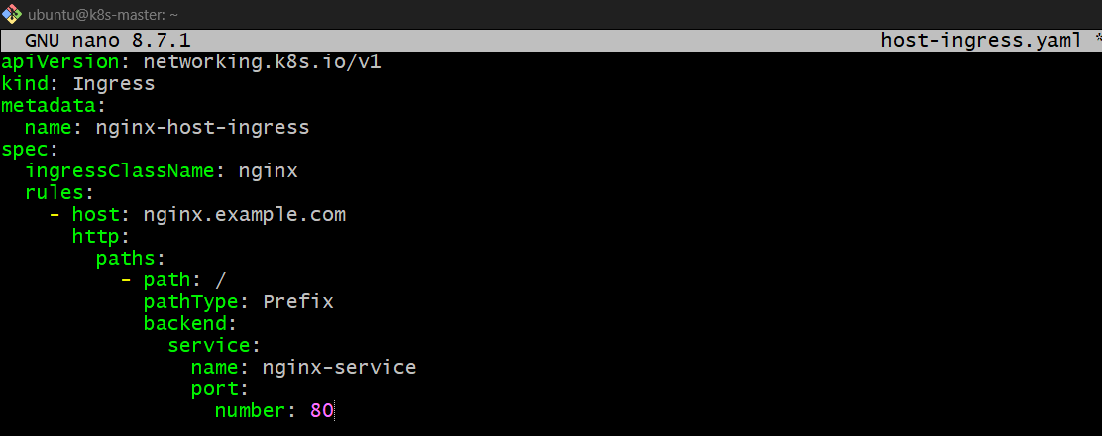
2. Apply
kubectl apply -f host-ingress.yaml 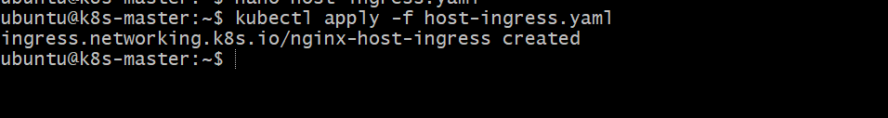
3. Verify
kubectl get ingress
kubectl describe ingress nginx-host-ingress
You should see:
Host: nginx.example.com
Path: /
Backend: nginx-service:80 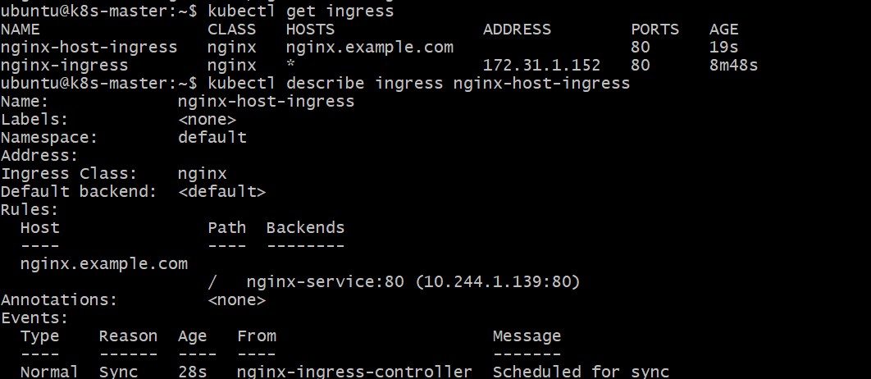
4. Test Without Real DNS
Since nginx.example.com is not actually registered, use your local hosts file.
On Windows, open Notepad as Administrator and edit:
C:\Windows\System32\drivers\etc\hosts
Add:
127.0.0.1 nginx.example.com
we try to access this domin but its loading because of its not register in any domin restry
5. Start SSH Tunnel
From Windows:
ssh -i "linux-key.pem" -L 32324:172.31.1.152:32324 ubuntu@ec2-44-200-35-208.compute-1.amazonaws.com
Keep it open.
6. Open Browser
Go to:
http://nginx.example.com:32324
You should get:
Welcome to nginx! ✅

- Upgrade k8s cluster from 1.26 to 1.28 Version. Note: Document to upgrade cluster. https://devopscube.com/upgrade-kubernetes-cluster-kubeadm/

Kubeadm Kubernetes Cluster Upgrade
Note: In this example, I will be upgrading Kubernetes version 1.34.0 to 1.34.6. Please replace the version numbers as per your existing version and upgrade requirement.
We need to run the upgrades in the following order
- Control plane node
- Worker Nodes
Also, we need to upgrade the following components on both the control plane and the worker nodes.
- Kubeadm
- Kubelet
- Kubectl
Upgrade The Control Plane
Following are the high level steps for the control plane upgrade
- Login to control plane
ssh -i "linux-key.pem" ubuntu@ec2-44-200-35-208.compute-1.amazonaws.com
- Check the existing version
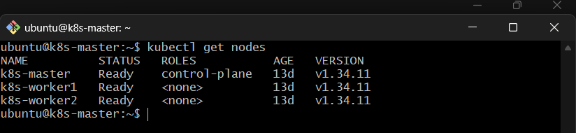
kubectl get pods

- unhold kubeadm and Install the latest kubeadm version
- Decide on the upgrade version by running a kubeadm upgrade plan (Same version patch or new version)
sudo kubeadm upgrade plan
- Apply Kubeadm upgrade
- Evict all workloads from control plane except daemonsets
- Upgrade kubectl and kubelet.
- Make the control plane schedulable (Uncordon)

Step 1: Check the existing Kubeadm version
Login to the control plane and can check the existing version using the following command.
kubeadm version -o json
You will get the following output.
{
"clientVersion": {
"major": "1",
"minor": "34",
"gitVersion": "v1.34.0",
"gitCommit": "f28b4c9efbca5c5c0af716d9f2d5702667ee8a45",
"gitTreeState": "clean",
"buildDate": "2025-08-27T10:15:59Z",
"goVersion": "go1.24.6",
"compiler": "gc",
"platform": "linux/arm64"
}
} 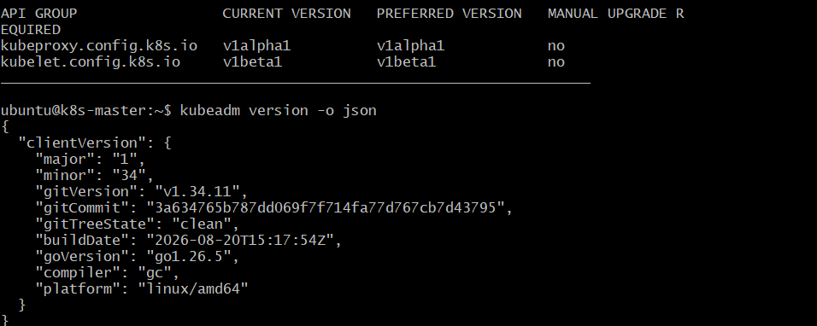
Step 2: unhold kubeadm and Install the latest version
During the Kubeadm cluster installation process, you would have hold the kubeadm installation to prevent upgrades.
Now we need to unhold kubeadm.
sudo apt-mark unhold kubeadm 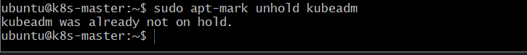
Check the available latest Kubeadm version using the following command.
sudo apt-cache madison kubeadm | tac
You will get the following output.
kubeadm | 1.34.0-1.1 | https://pkgs.k8s.io/core:/stable:/v1.34/deb Packages
kubeadm | 1.34.1-1.1 | https://pkgs.k8s.io/core:/stable:/v1.34/deb Packages
kubeadm | 1.34.2-1.1 | https://pkgs.k8s.io/core:/stable:/v1.34/deb Packages
kubeadm | 1.34.3-1.1 | https://pkgs.k8s.io/core:/stable:/v1.34/deb Packages
kubeadm | 1.34.4-1.1 | https://pkgs.k8s.io/core:/stable:/v1.34/deb Packages
kubeadm | 1.34.5-1.1 | https://pkgs.k8s.io/core:/stable:/v1.34/deb Packages
kubeadm | 1.34.6-1.1 | https://pkgs.k8s.io/core:/stable:/v1.34/deb Packages
In my case the latest version is 1.34.6-1.1. Update and install the latest version using the following command. Replace the version number you get from the output. 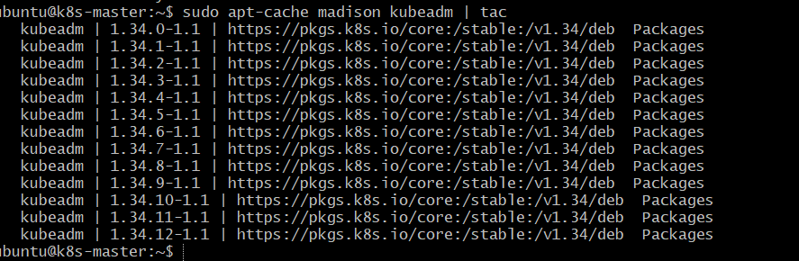
sudo apt-get update -y 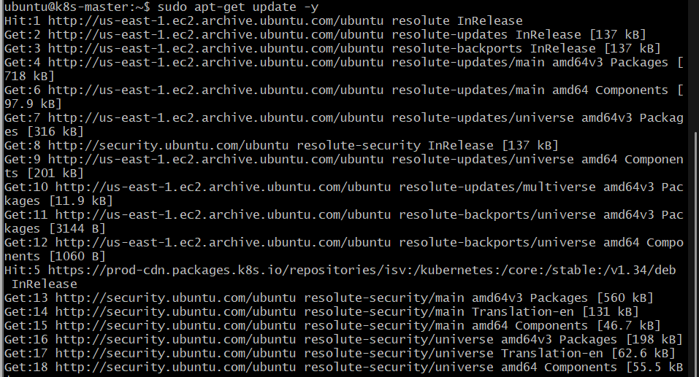
sudo apt-get install -y kubeadm= 1.34.12-1.1 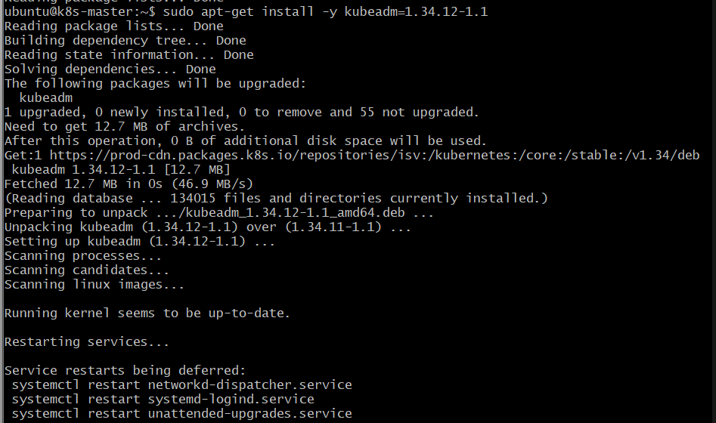
Hold kubeadm package.
sudo apt-mark hold kubeadm 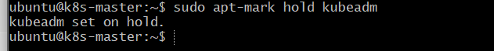
Step 3: Decide on the upgrade version
You can get the list of available kubernetes version using the kubeadm upgrade plan.
sudo kubeadm upgrade plan 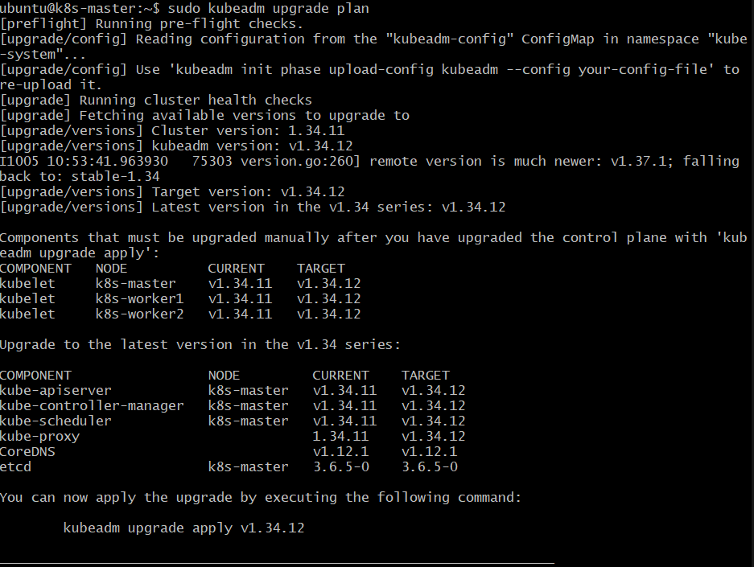
The output will show the version that can be applied for the upgrade. In my case the version to be upgraded is v1.34.6. Change this version as per your output.
Step 4: Apply Kubeadm upgrade
Apply the upgrade using the following command with the version.
kubeadm upgrade apply v1.34.12
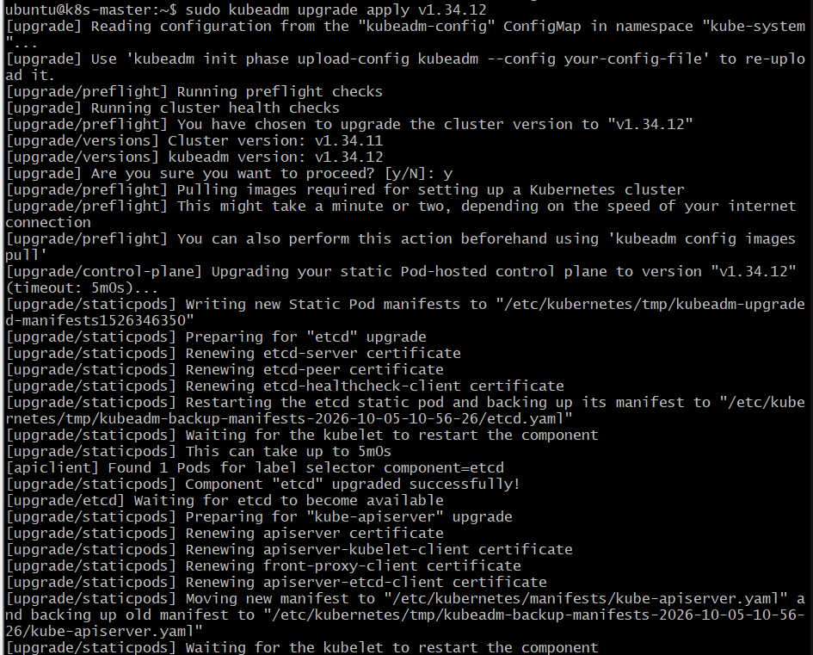
Now if you check the kubeadm version, you can see the upgraded version.
{
"clientVersion": {
"major": "1",
"minor": "34",
"gitVersion": "v1.34.12",
"gitCommit": "8b2bf66ce7018f6e13e8767624d4ce7768a8a2e5",
"gitTreeState": "clean",
"buildDate": "2026-03-18T19:18:06Z",
"goVersion": "go1.24.13",
"compiler": "gc",
"platform": "linux/arm64"
}
}
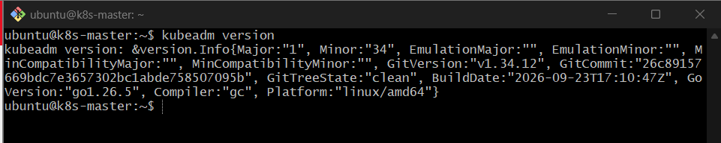
Step 6: Drain the Node to evict all workloads.
To apply the upgrade we nee to evict all the workloads except daemonsets using the following command. Replace controlplane with your controlplane node name.
kubectl drain controlplane --ignore-daemonsets 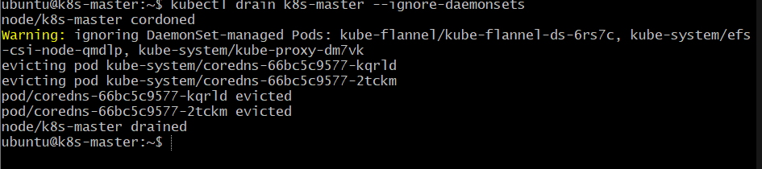
Step 7: Upgrade Kubelet and Kubectl.
Unhold and upgrade kubectl and kubelet using the following commands.
sudo apt-mark unhold kubelet kubectl 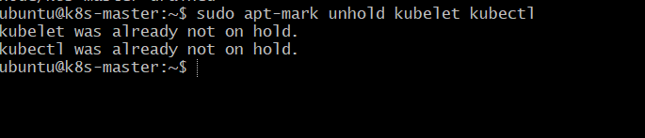
sudo apt-get update 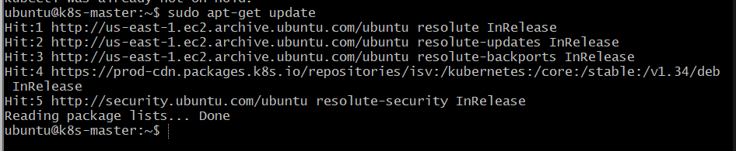
sudo apt-get install -y kubelet=1.34.12-1.1 kubectl=1.34.12-1.1 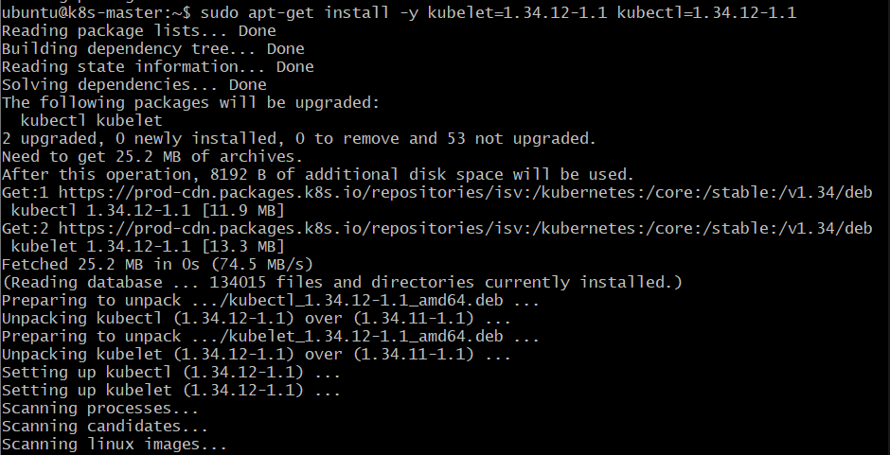
sudo apt-mark hold kubelet kubectl 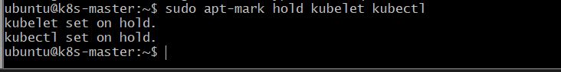
Restart the services.
sudo systemctl daemon-reload
sudo systemctl restart kubelet 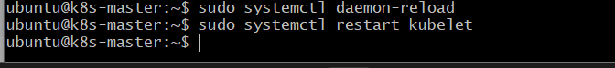
Step 7: Uncordon the Node and Verify the Node Status
Use the following command to uncordon the control plane node
kubectl uncordon k8s-master 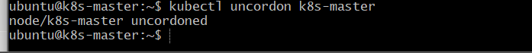
Verify the node status and version using the following command.
kubectl get nodes
You can see the control plane upgraded to the new version and nodes running on the old version as shown below.
NAME STATUS ROLES AGE VERSION
controlplane Ready control-plane 7d7h v1.34.6
node01 Ready worker 7d7h v1.34.0
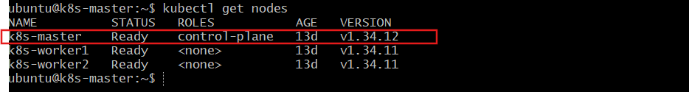
Upgrade Worker Nodes
Worker node upgrade steps are similar to control plane upgrade. However the internal upgrade process differ from control plane.
All the following steps should be executed on the Worker node. If you have multiple worker nodes, upgrade one at a time.
Step 1: Unhold Kubeadm and Install Required Version
Install the required version of Kubeadm on worker nodes. Replace 1.34.6-1.1 with you version.
sudo apt-mark unhold kubeadm
sudo apt-get update && sudo apt-get install -y kubeadm=1.34.6-1.1
sudo apt-mark hold kubeadm 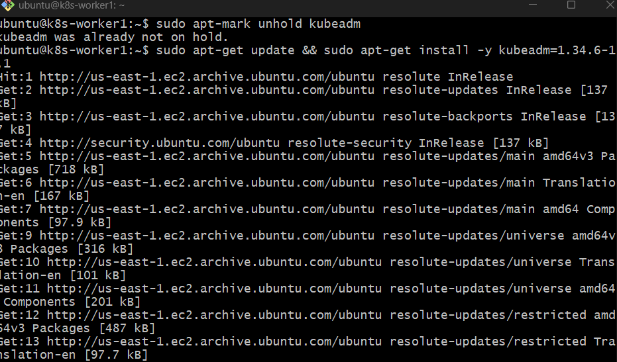

Step 2: Upgrde Kubeadm
As you are running the following command on a worker node, it skips all the steps required for the control plane and update only kubelet configuration required for a worker node.
sudo kubeadm upgrade node 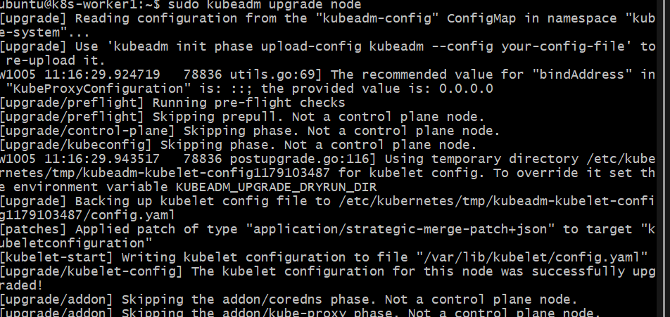
Step 3: Drain the Node
Evict all the pods on the worker node by draining it. Replace node01 with your worker node name. Execute this command from terminal where you have kubectl access.
kubectl drain node01 --ignore-daemonsets 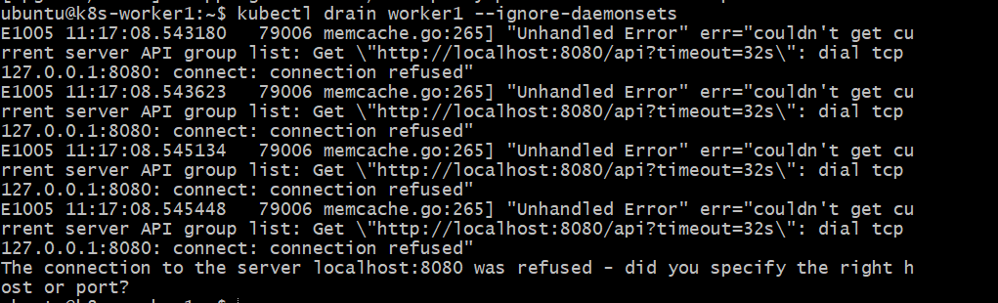
If pods are using local storage, you might get the following error. This is mostly occur in vagrant setup. In CKA exam, you will not probably face this issue.
error: unable to drain node "node01" due to error:cannot delete Pods with local storage (use --delete-emptydir-data to override): kube-system/metrics-server-69fb86cf66-nqmhn, continuing command...
There are pending nodes to be drained:
node01
cannot delete Pods with local storage (use --delete-emptydir-data to override): kube-system/metrics-server-69fb86cf66-nqmhn
To rectify that issues, you need to add the --delete-emptydir-data as well.
kubectl drain node01 --ignore-daemonsets --delete-emptydir-data
Step 4: Upgrade Kubelet & Kubectl
Run these commands on worker nodes
sudo apt-mark unhold kubelet kubectl
sudo apt-get update 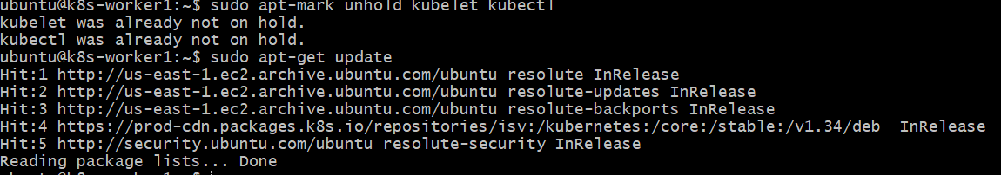
sudo apt-get install -y kubelet=1.34.12-1.1 kubectl=1.34.12-1.1 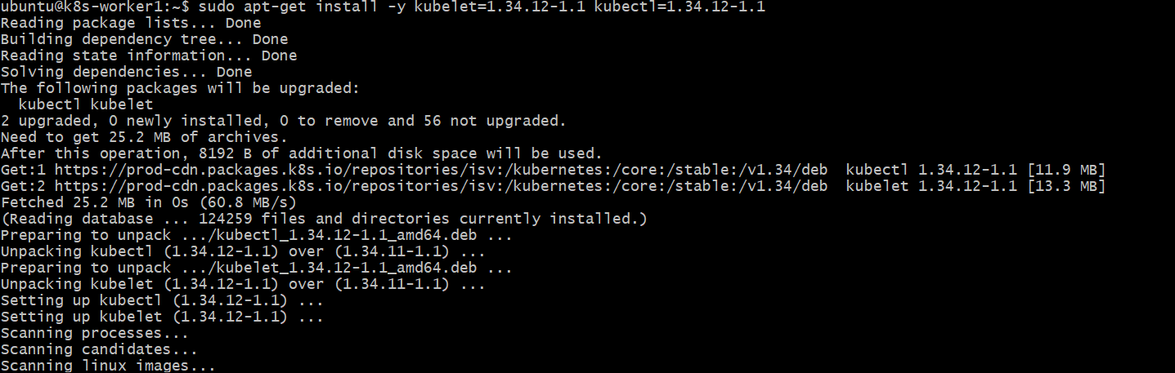
sudo apt-mark hold kubelet kubectl 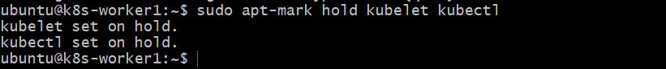
sudo Restart kubelet
sudo systemctl daemon-reload
sudo systemctl restart kubelet 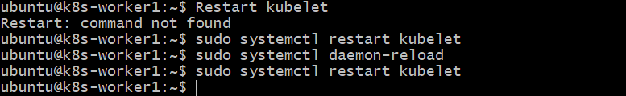
Step 5: Uncordon worker node from master
Execute the following uncordon command from the node where you have kubectl access.
kubectl uncordon worker1
Verify Cluster Upgrade-master
Now that we have upgraded the control plane node and the worker nodes, lets verify if the cluster is upgraded and working as expected.
Get the node information
kubectl get nodes 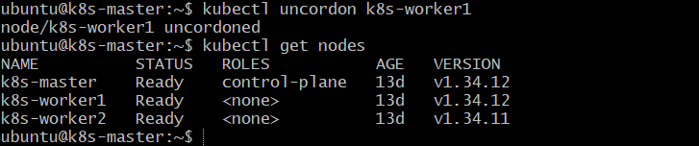
You should see the control plane and worker nodes upgraded to the specified version.
NAME STATUS ROLES AGE VERSION
controlplane Ready control-plane 7d8h v1.34.6
node01 Ready worker 7d7h v1.34.6
From the control plane node, you can use any one of the following kubectl commands to check the status of all the cluster components.
kubectl get --raw='/readyz?verbose'
curl -k https://localhost:6443/livez?verbose
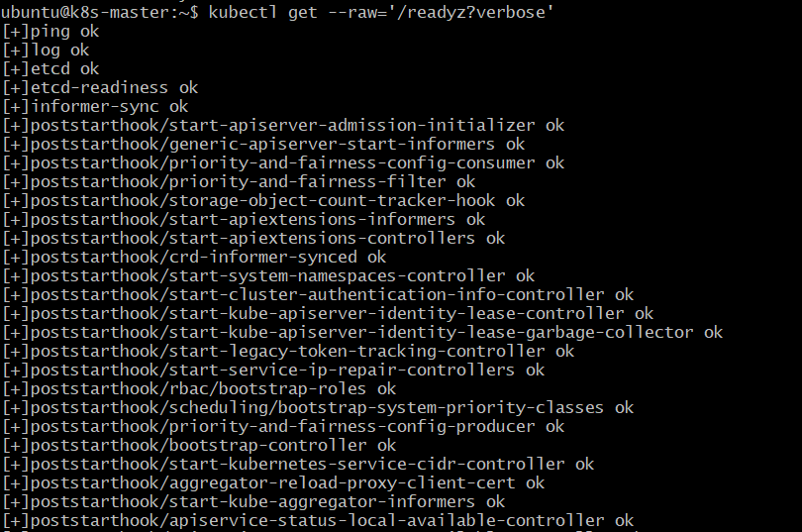
Also, check if all the kube-system control node pods are running.
kubectl get po -n kube-system 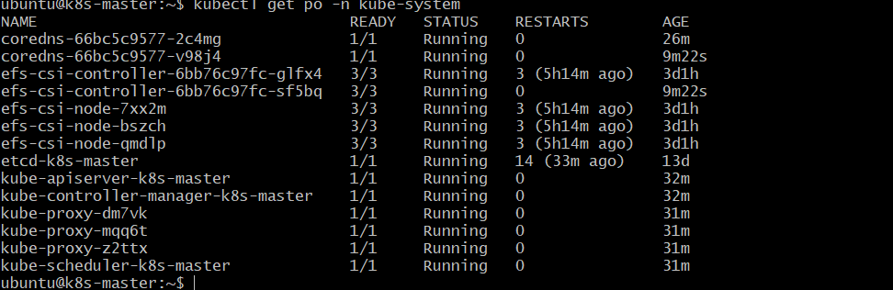

Conclusion
Kubeadm utility helps you upgrade the Kubernetes cluster control plane and worker nodes without downtime. Ensure you verify the cluster and application status after the upgrade.

